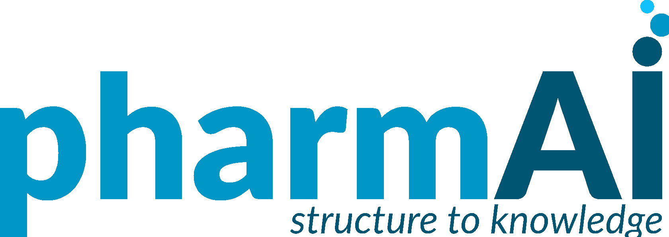

Dresden/Munich, April 6th 2022

Press Release

NanoTemper Technologies and PharmAI launch Proto, a free AI tool to quickly determine which protein labeling strategy works best for molecular interaction measurements

NanoTemper Technologies, in partnership with PharmAI, announced the launch of Proto, a free AI-based web application that reveals the best labeling strategy to help scientists more efficiently measure molecular interactions, a process that’s necessary to discover and develop new drugs. Proto is one the first commercial applications using the AlphaFold protein structure database that was made freely accessible by EMBL-EBI and DeepMind, an Alphabet company.

Scientists in drug discovery need to detect and measure how well proteins bind to molecules, which requires labeling, usually with the aid of a dye. If the wrong labeling strategy is chosen, it leads to time-consuming and costly investigations.

"Proto makes use of more than 700,000 protein structures from AlphaFold or from the RCSB Protein Data Bank to suggest the appropriate dye for binding measurements," explains Christina Wolf, Data Scientist at NanoTemper. "This makes binding measurements more efficient and reliable, and it gives scientists additional confidence in their results."

This novel labeling prediction is another important step towards optimizing experiments in the field of biotechnology and the pharmaceutical industry with the help of artificial intelligence. "We want to help optimize research into diseases and therapeutics — that’s why we are making the tool free of charge," says Philipp Baaske, Co-CEO of NanoTemper. “There are numerous rare diseases that are currently unprofitable for large pharmaceutical companies to study. The possibilities offered by AI-based software could enable smaller laboratories to enter the field of drug research in the future and make new therapies possible with their work, benefiting us all,” adds Joachim Haupt, CEO of PharmAI.

Experience Proto for yourself; visit proto.nanotempertech.com.

About PharmAI
PharmAI's mission is to make early-stage drug development significantly more efficient by increasing success rates while reducing costs. This is achieved through a breakthrough AI-powered platform for 3D protein structure analysis. This technology will dramatically shorten the timeline for discovering new therapeutic molecules. PharmAI was founded in 2019 as a spin-off of the Technische Universität Dresden.

www.pharm.ai

About NanoTemper Technologies
Our mission at NanoTemper Technologies is to create biophysical tools for scientists in drug discovery and development who need to tackle challenging characterizations. Working with scientists striving to make a difference in the world gets us excited. If you’re facing challenges with affinity screening, molecular interactions, protein stability, protein expression, or protein quality, let’s talk.

www.nanotempertech.com
Free photos for this press release are available at www.pharm.ai/press/

Contact for press inquiries:

PharmAI GmbH  Jana Mundus  +49 351-41881626  press@pharm.ai | NanoTemper Technologies GmbH  John Valdez  +1 415 670-0424  john.valdez@nanotempertech.com

